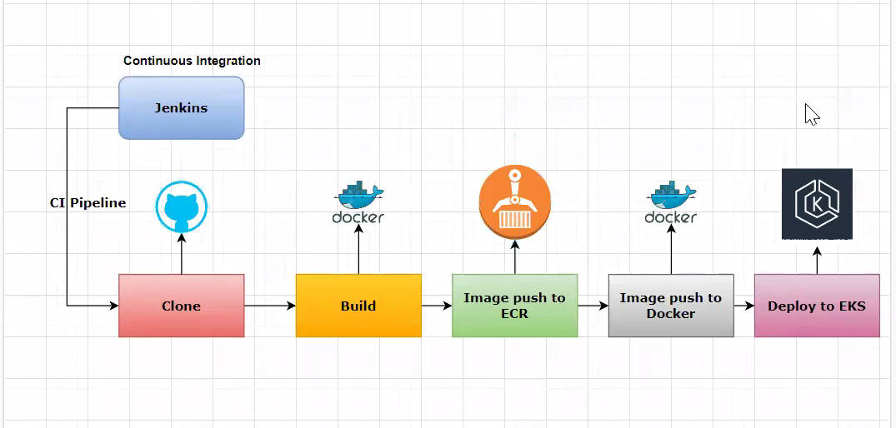

**Install docker.sh**

<https://raw.githubusercontent.com/Msocial123/docker-install-commands/master/docker-install.sh>

curl https://raw.githubusercontent.com/Msocial123/docker-install-commands/master/docker-install.sh | sudo bash

**Install AWS CLI and other components:**

[**https://raw.githubusercontent.com/Msocial123/k8-install-eks/master/eks-client.sh**](https://raw.githubusercontent.com/Msocial123/k8-install-eks/master/eks-client.sh)

curl https://raw.githubusercontent.com/Msocial123/k8-install-eks/master/eks-client.sh | sudo bash

Install Helm :

curl -fsSL -o get_helm.sh <https://raw.githubusercontent.com/helm/helm/main/scripts/get-helm-3>

chmod 700 get_helm.sh

./get_helm.sh

sudo chmod +x linux-amd64/helm && sudo mv linux-amd64/helm /usr/bin/helm

helm version --short

**Add Jenkins user:**

**Sudo usermod –aG docker Jenkins**

**Install Below Plugins :**

**Install Docker**

**Configure Docker**

**Install AWS Credencials**

**Install AWS Steps**

**Add Docker Cloud :**

**Add AWS Credentials:**

**Docker Pipeline**

**Clone**

**Unit Tests**

**Scans**

**Static Source analysis with SonarQube**

**Helm Repository URL :** [**https://github.com/prometheus-community/helm-charts/tree/main/charts/prometheus**](https://github.com/prometheus-community/helm-charts/tree/main/charts/prometheus)

**Install Helm Charts :**

[**https://prometheus-community.github.io/helm-charts/**](https://prometheus-community.github.io/helm-charts/)

**Install Helm :**

[**https://helm.sh/docs/**](https://helm.sh/docs/)

**kubectl expose service prometheus-server --type=NodePort --target-port=9090 --name=prometheus-server-ext**

**Install using Helm**

**Add helm repo**

**helm repo add grafana https://grafana.github.io/helm-charts**

**Update helm repo**

**helm repo update**

**Install helm**

**helm install grafana grafana/grafana**

**Expose Grafana Service**

**kubectl expose service grafana — type=NodePort — target-port=3000 — name=grafana-ext**

**Install on Ubuntu :**

**Install using APT repository in Ubuntu or Debian**

**Install packages**

**sudo apt-get install -y apt-transport-https software-properties-common wget**

**## Import GPG key**

**sudo mkdir -p /etc/apt/keyrings/ wget -q -O - https://apt.grafana.com/gpg.key | gpg --dearmor | sudo tee /etc/apt/keyrings/grafana.gpg > /dev/null**

**## Add repository for stable release**

**echo "deb [signed-by=/etc/apt/keyrings/grafana.gpg] https://apt.grafana.com stable main" | sudo tee -a /etc/apt/sources.list.d/grafana.list**

**Update the list of available packages**

**sudo apt-get update**

**Install Grafana OSS**

**sudo apt-get install Grafana**